Colab Link - [Link for Colab](https://colab.research.google.com/drive/1tvi5pvonI3gULHu12lguhuKlhJkJq2zu#scrollTo=W-y5Cf5aqm0h&uniqifier=2)

a) Import the data file (spotify_preprocessed.csv) to your code. The data is preprocessed and ready to use.

***Importing the require libraries:***

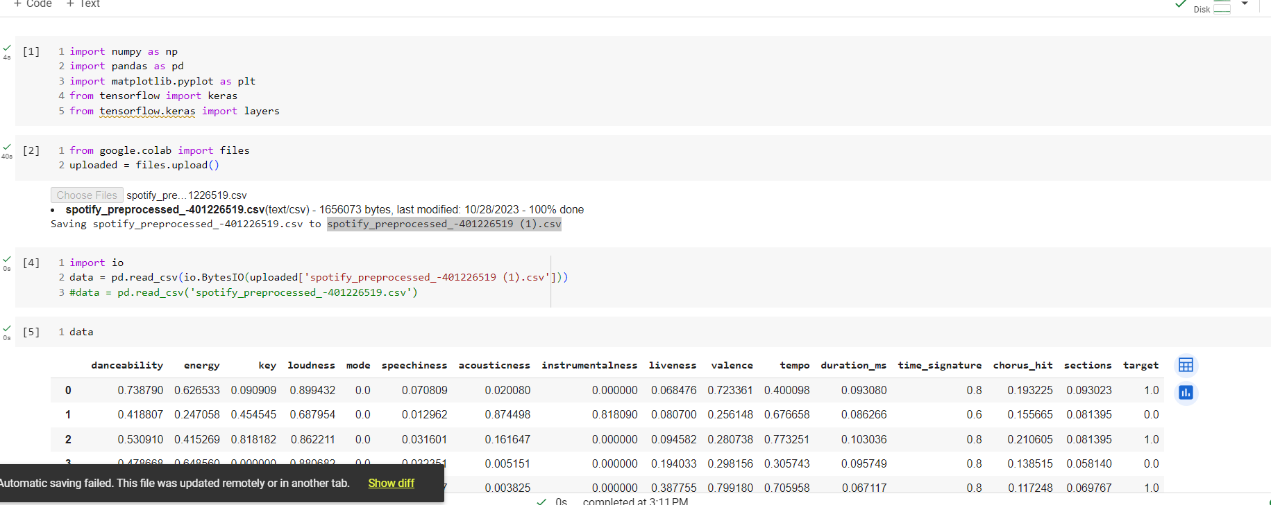

b) Shuffle the data then split it into training (90% of the data) and test set (10% of the data). Split the training set further into training and validation sets with 80% and 20% percentages respectively.

***Shuffling the data:***

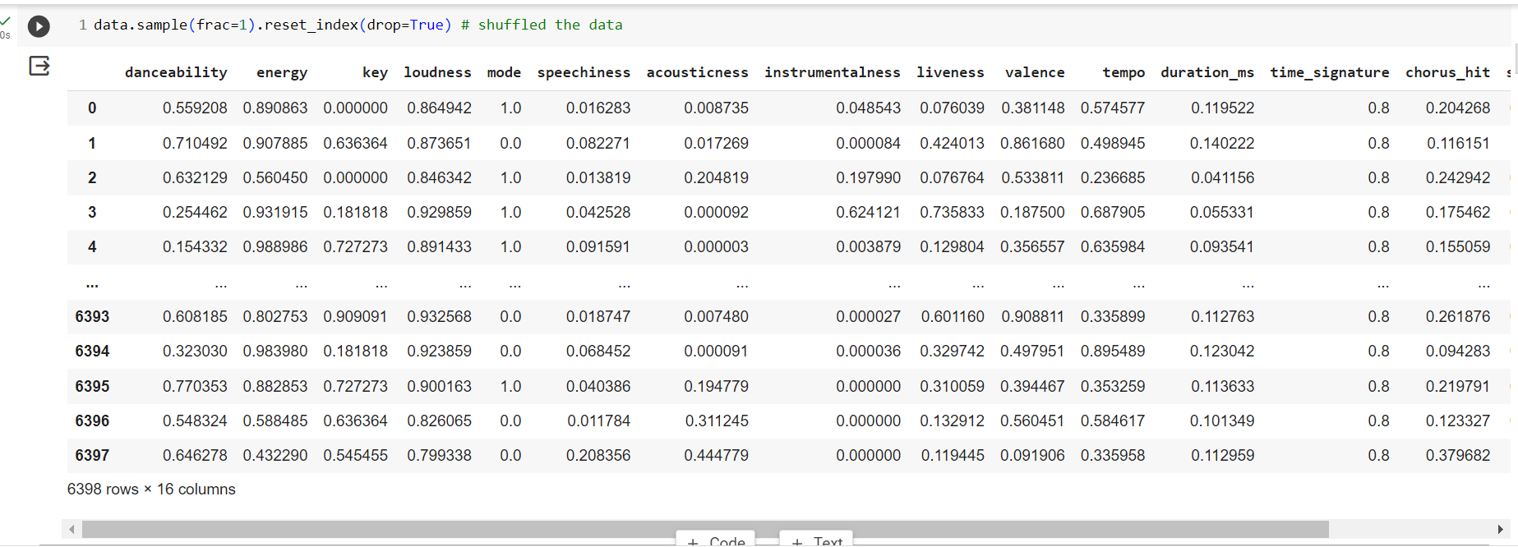

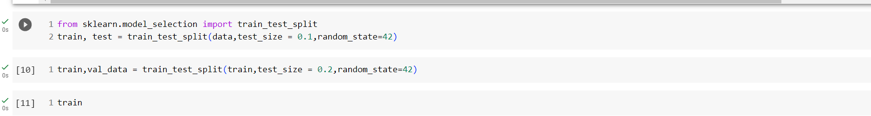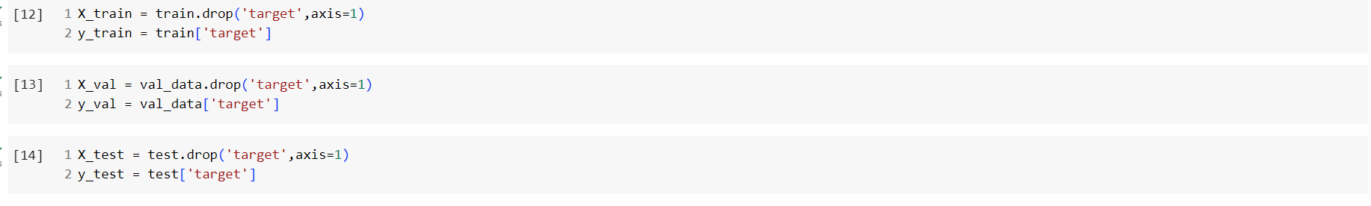



c) Build, compile, train, and then evaluate:

* Build a neural network with 2 hidden layers that contain 32 nodes each and an output layer that has 1 unit using the Keras library.
* Compile the network. Select binary cross-entropy (binary_crossentropy) as the loss function. Use stochastic gradient descent learning (SGD, learning rate of 0.01).
* Train the network for 50 epochs and a batch size of 16.
* Plot the training loss and validation loss (i.e., the learning curve) for all the epochs. 2 e. Use the evaluate() Keras function to find the training and validation loss and accuracy.

***Building the model with all the above mentioned criteria and evaluating the corresponding losses:***

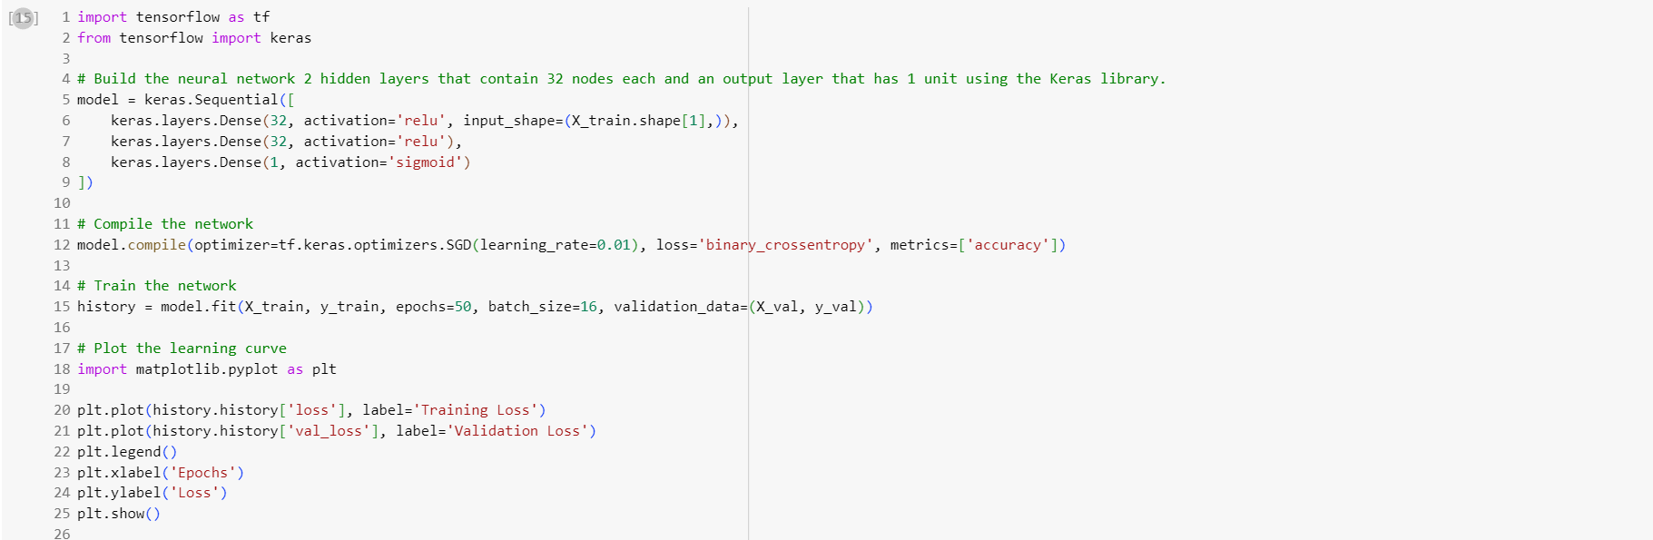

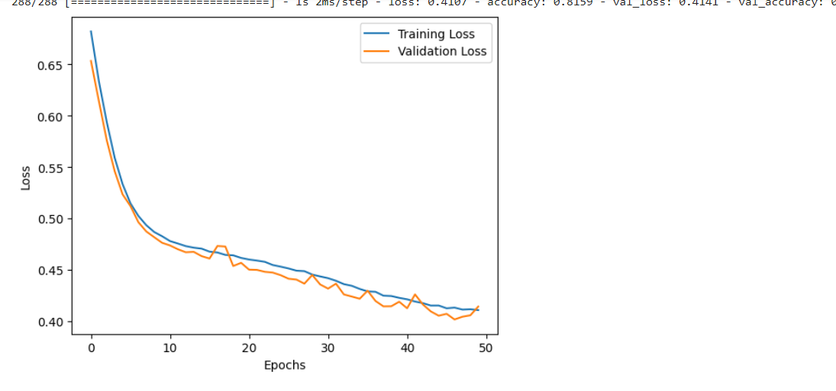

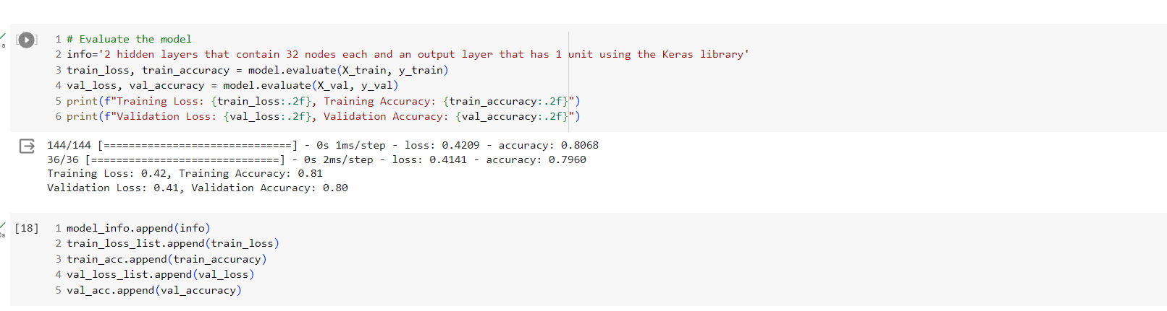

d) Try different design ideas with the model until you get the best training and validation performance. For example, changing the number of hidden layers and number of units in each, changing the loss function, the learning algorithm, the learning rate, number of epochs and the batch size. Repeat the scores in a table.

***Trying for different combinations as mentioned above:***

***For 3 layers, 64,32,32, binary_crossentropy, epochs=50,activation=sigmoid,optimize=SGD, batch_size=16***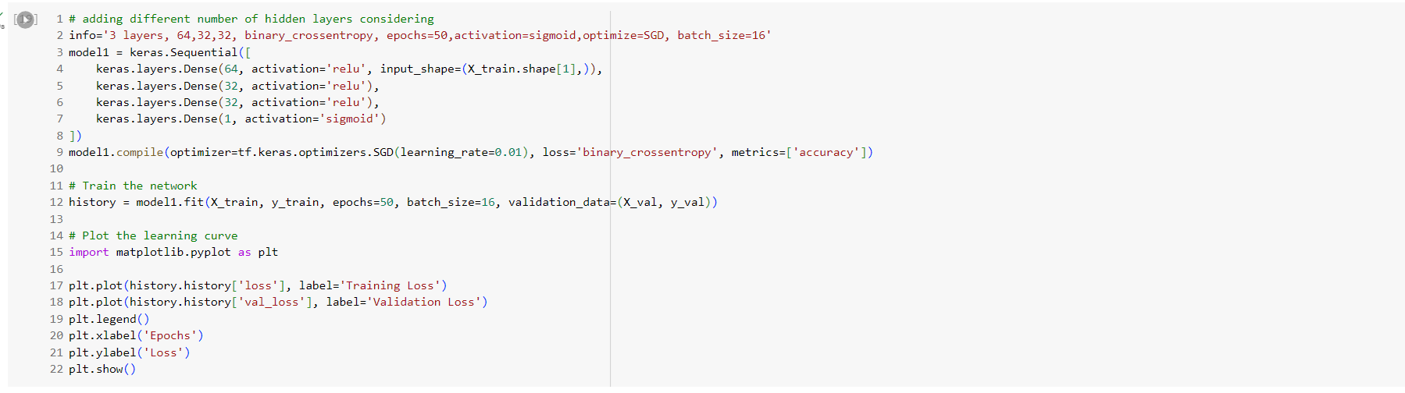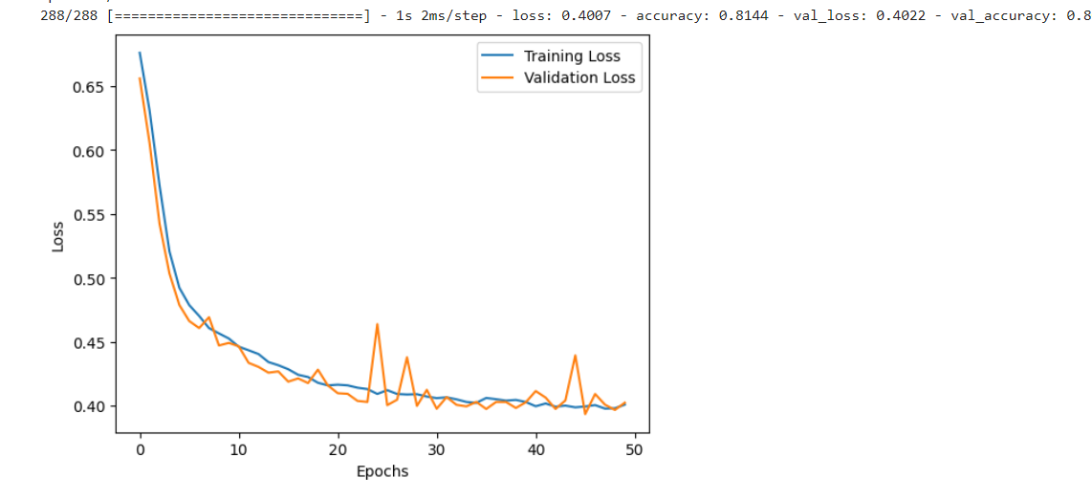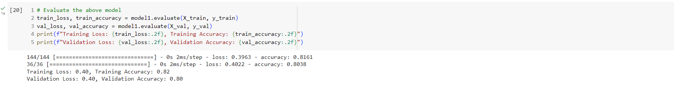

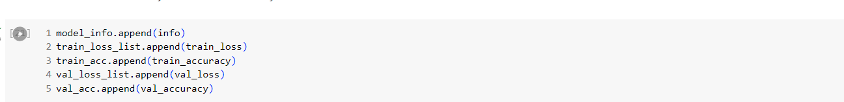

***For 2 layers, mean_squared_error, epochs=50,activation=sigmoid,optimize=SGD, batch_size=16***

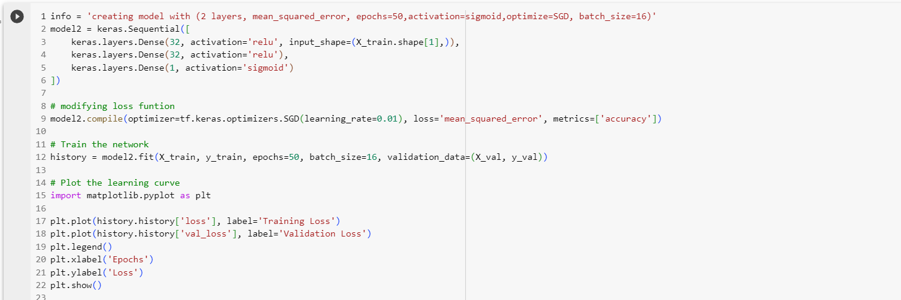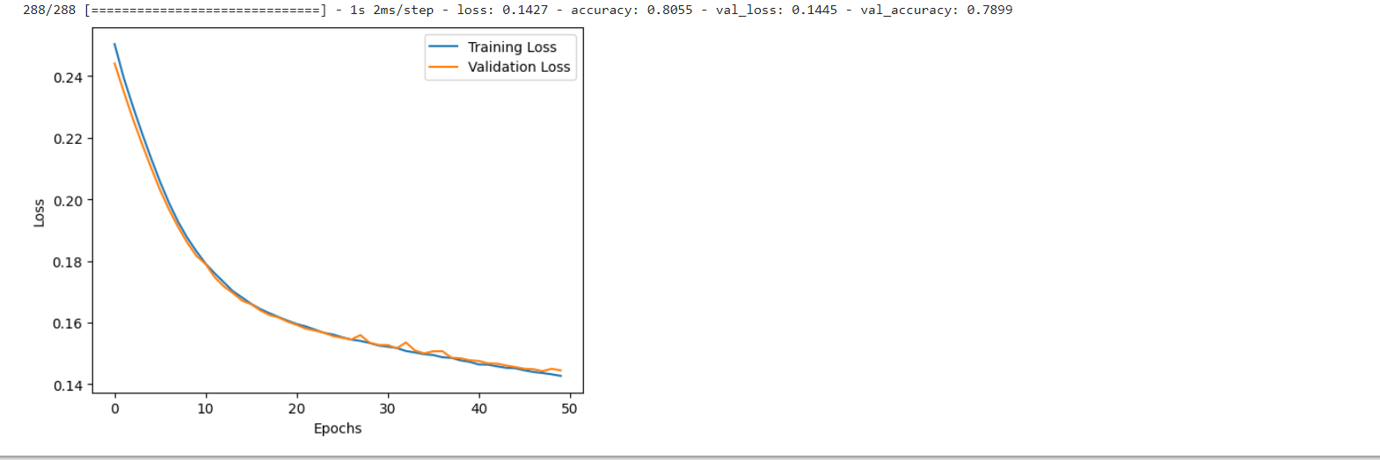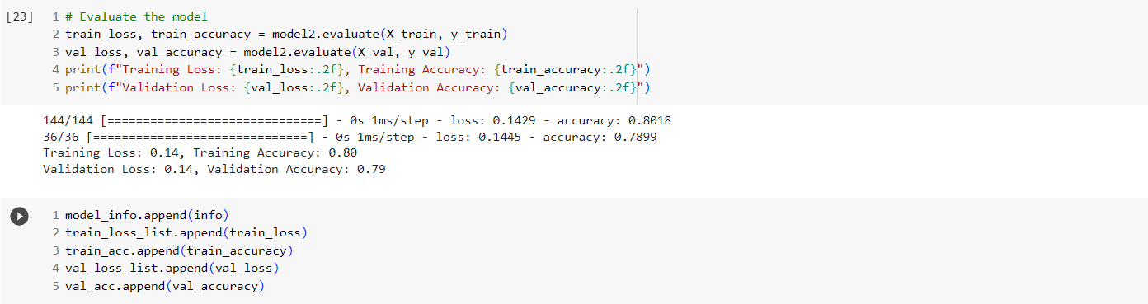

***For2 layers, binary_crossentropy, epochs=50,activation=sigmoid,optimize=Adam, batch_size=16:*** 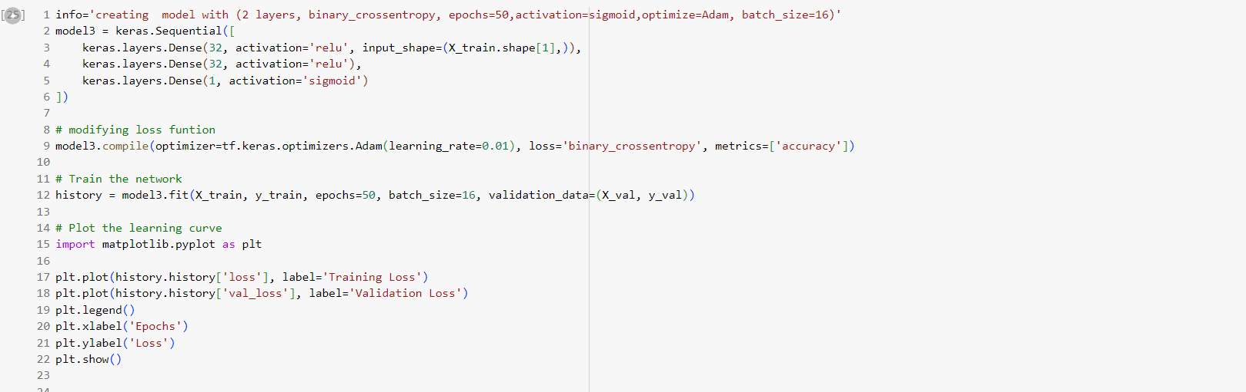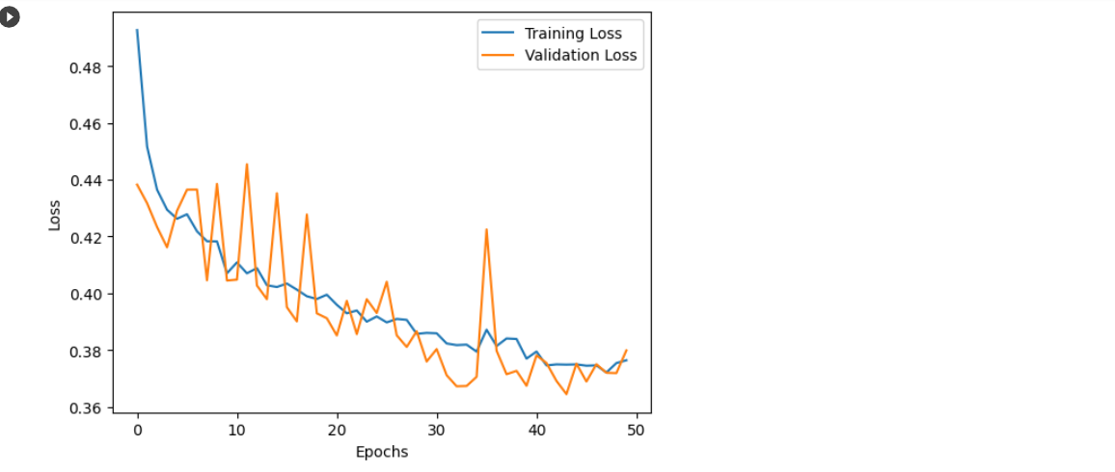

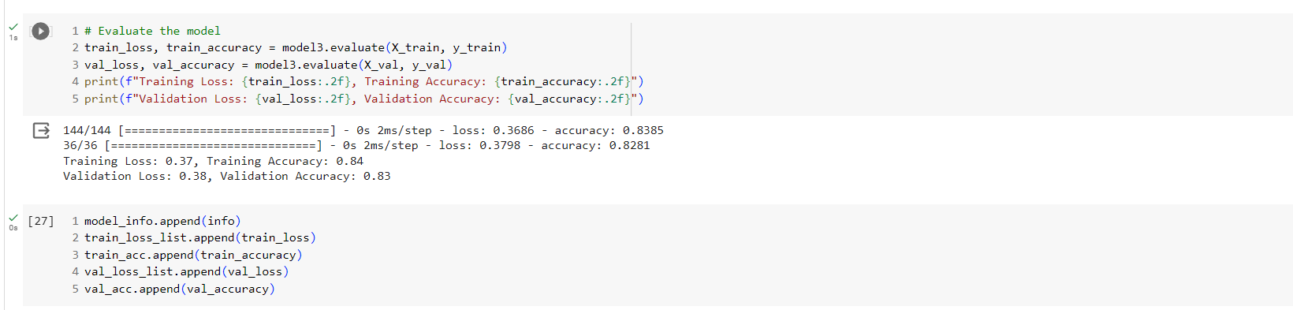

***For2 layers, binary_crossentropy, epochs=100,activation=sigmoid,optimize=SGD, batch_size=16:***

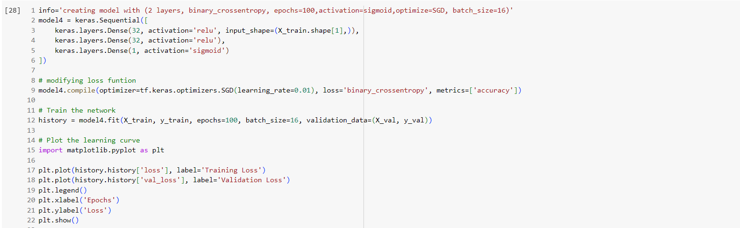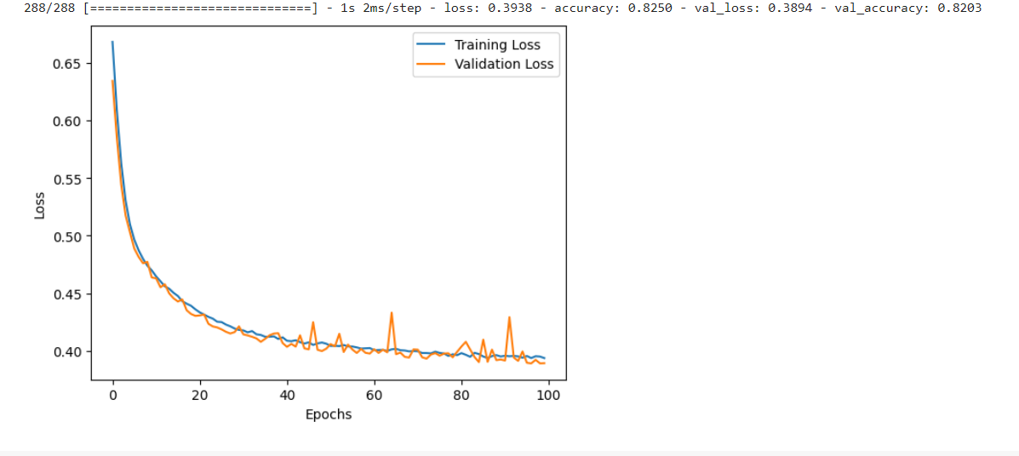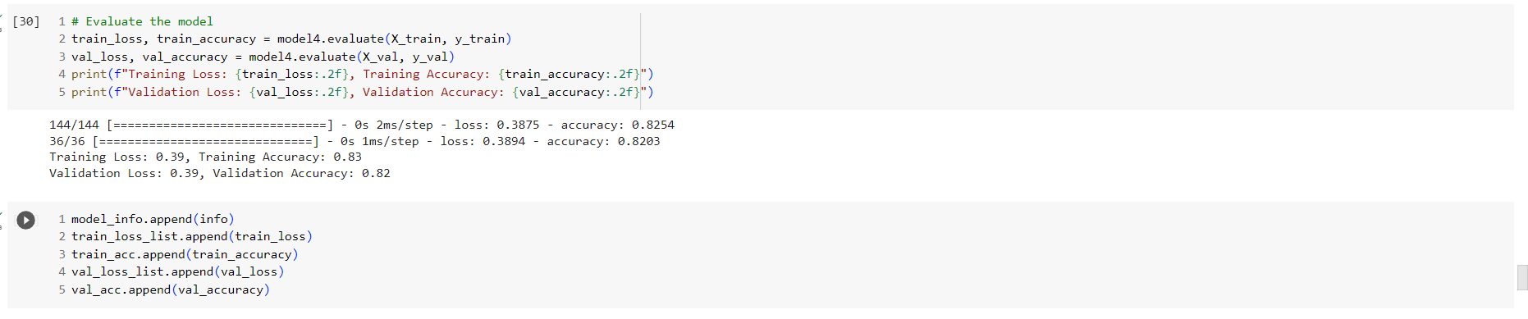

***For2 layers, binary_crossentropy, epochs=50,activation=sigmoid,optimize=SGD, batch_size=32:***

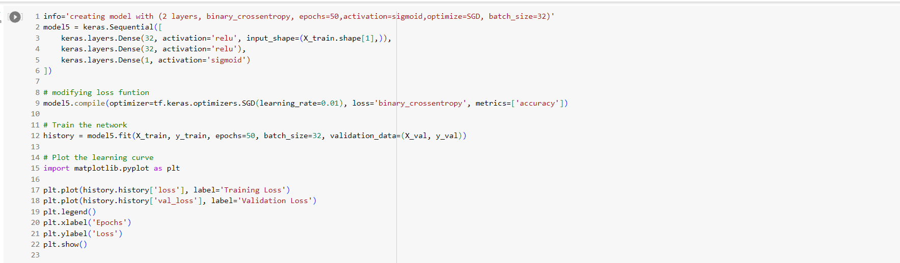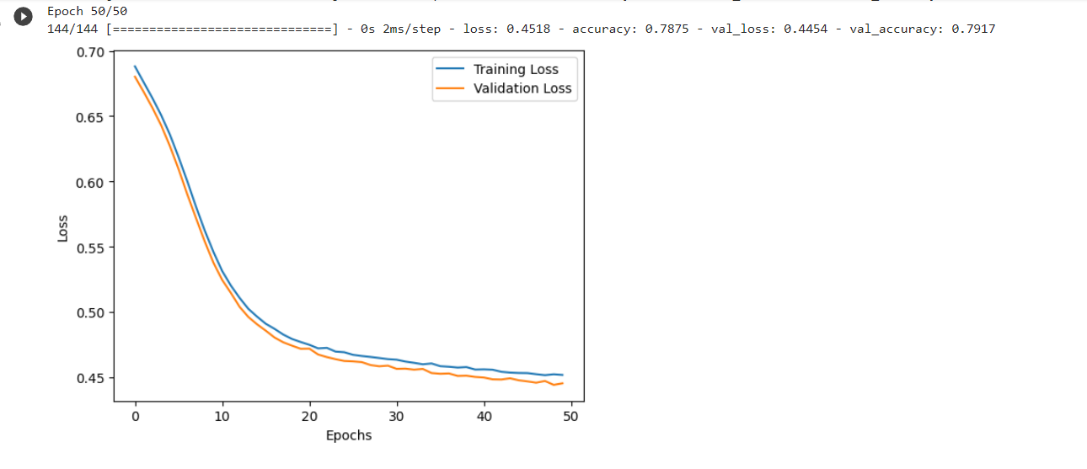

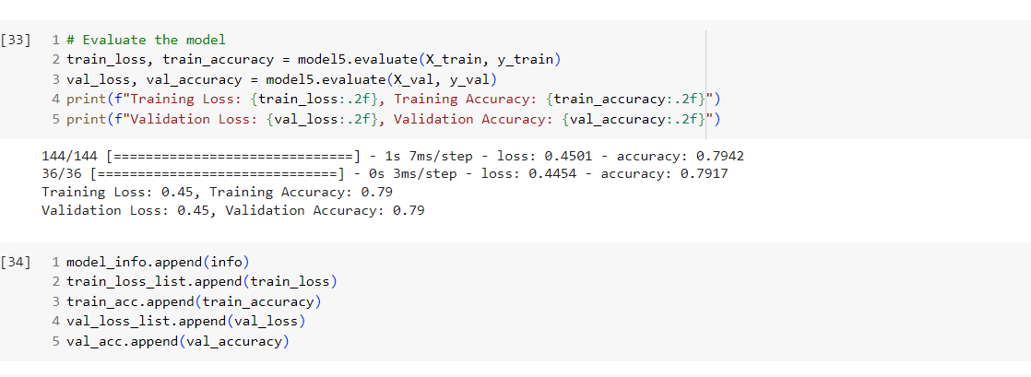

***For 2 layers, binary_crossentropy, epochs=50,activation= softmax,optimize=SGD***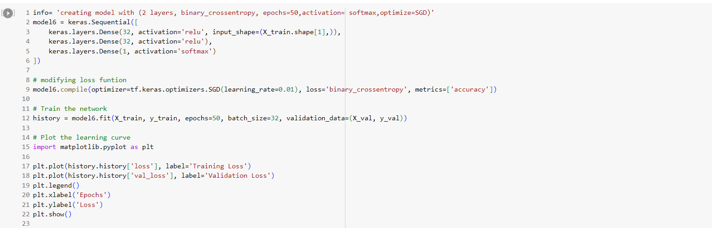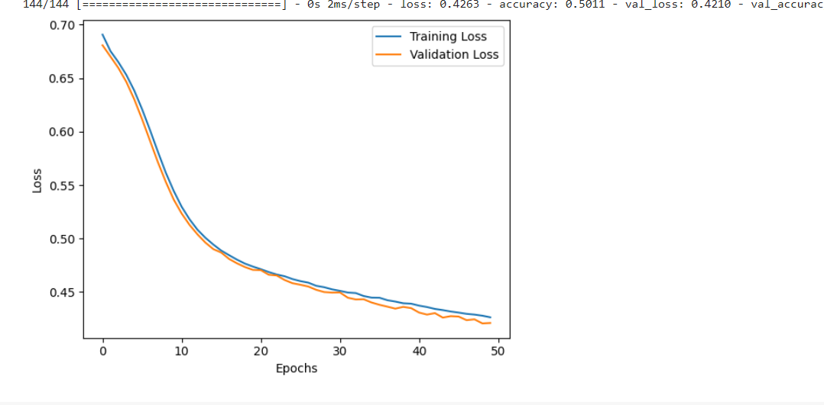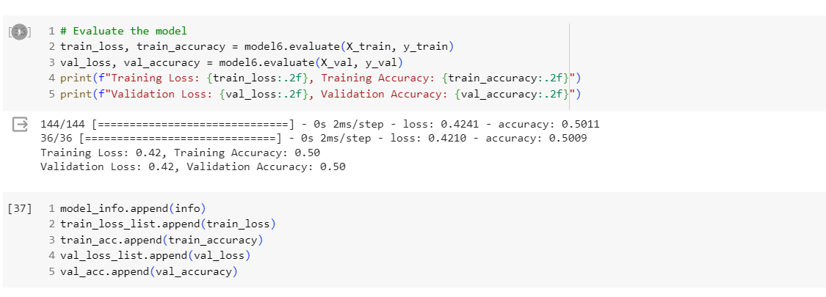

e) Repeat parts (c) and (d) and select the model with the best performance. 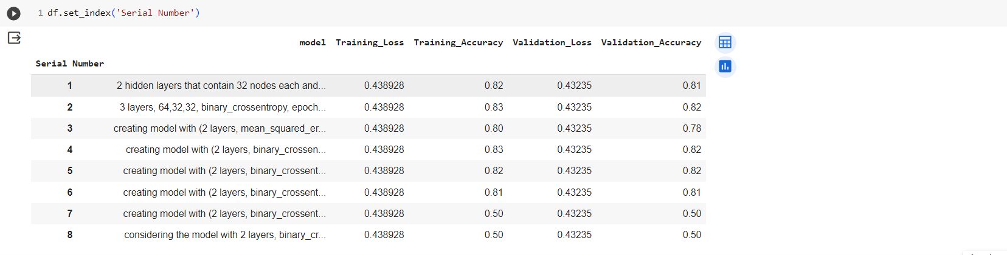

***Considering 2 layers, binary_crossentropy, epochs=50,activation=sigmoid,optimize=Adam, batch_size=16 which is model 3 from the above with the respective parameters***

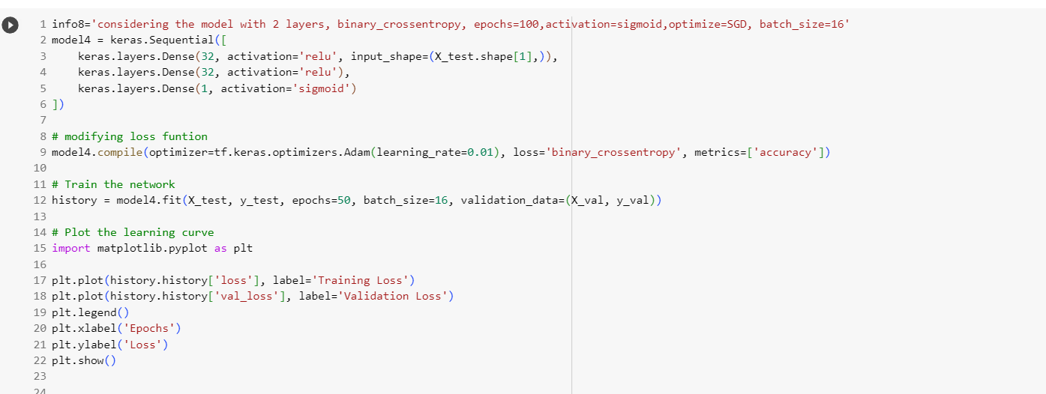

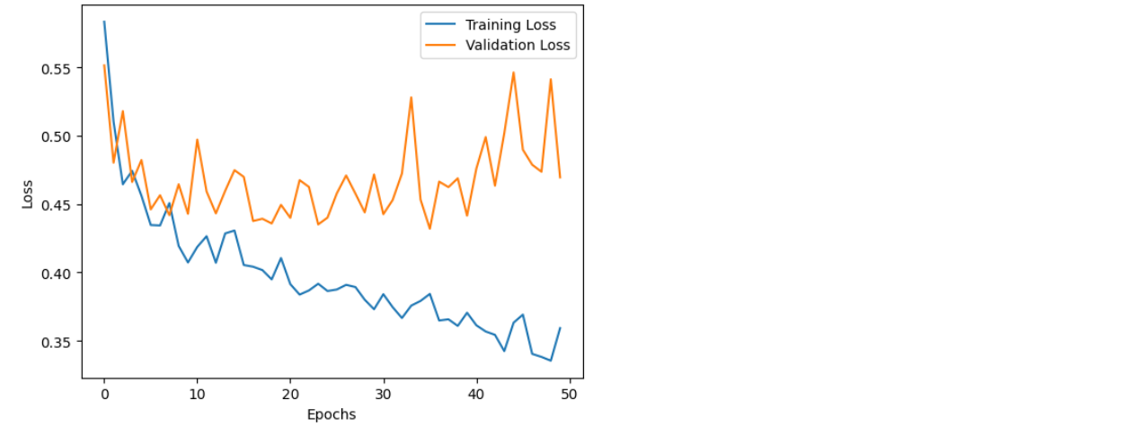

f) Evaluate the selected model on the test set and report the testing loss and accuracy.

